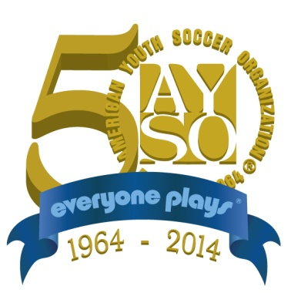 

**AYSO Camarillo Region 68**

**2014 / 2015 Secondary Season**

**Coaches-Players-Parent Conduct Letter of Agreement**

Congratulations, you have been selected as an Ambassador for AYSO Camarillo Region 68!

As you start your secondary season, the Region asks you the Coaches, Players and Parents to adhere to the following standards of conduct for the secondary season.

Please read the following standards for the secondary season 2013-2014:

1. Practice good sporting behavior at all times.

2. Playing ¾ of all matches is the standard expectation. Understand that each player must and is entitled to play at least ½ of every game.

3. Respect coaches, parents, referees and teammates of all competing teams.

4. Using profanity (cussing, swearing, etc.) is not acceptable. Coaches/Players who choose to use profanity are subject to due process per the Region 68 guidelines.

5. Violent conduct, threatening, verbal or physical dissension is not acceptable by any Coach, players or Parent.

Please print your name sign and date:

I/we, ____________________________________________, understand these standards of conduct and agree to abide by them.

___________________________

Player Signature

_______________________________ _______________________________

Parent Signature Parent Signature

_________ _______ ___________

Date Division Team Number